Assignment 4 – Application design

Ruby Havelaar, 21248462

Temmuz Sureyya Gurbuz

1MDM1 Digital Media

10/05/2022

Mobile application

I am going to make a mobile application that I can combine with my final project.

The app will have information about the campaign I am making and the animals and products it is about.

The aesthetic of the app is the same color scheme I will most likely use for my final project. It is black and white with only certain images showing color. This is because I do not want anything to distract from the main purpose of the app, which is to inform people about a very serious topic. I have already created a logo which consists of the three animals I will be researching for my final project: the mountain gorilla, the Javan rhinoceros and the snow leopard. There must be a strong contrast between the text and the background for it to be clearer to read for the user. I think eventually it would be a great idea to have a light and dark mode for the app, which would work with the current style being black and white.

(Logo and submarks)

The app is mainly for information and a user / account creation will not be necessary up to this point. This might change the more I start working on the app and find new ideas. The app will have information about the campaign, why it was created, who created it, and the animals it includes. There will be information about the animals and why they are classified as critically endangered or vulnerable. There will also be info about what we can do and what products we can stop consuming to help such as palm oil (8 things to know about palm oil). There will also be a page where people can donate and sign petitions which is quite often seen nowadays through links on social media account and emails. The app also contains links to the social media accounts created for the campaign. The website link is a link to my portfolio that has a page about the campaign in it as I have not made a website for the campaign yet. There is a page (like mentioned before) in the app that informs about certain products we as humans can stop using to help the endangered animals. The app itself is small, because the main purpose for it is to inform and receive donations and signatures for petitions.

I created the app design and prototype using Adobe XD as this is a program I have worked with before and have more knowledge of. The profile pictures of the team on the “About” page was generated using a plug-in which selects random profile photos. The other photos were edited using Adobe Photoshop.

I started searching for apps that, like mine, do not need wi-fi for most purposes of the app. Most of these were games to play on your phone. There are apps like, google maps and Spotify that allow the user to listen to their downloaded music or download a route for travels. The purpose of my app is to be informed, and with wi-fi, be able to donate and sign petitions. There are lots of apps that do not need wi-fi to make use of it, such as many music apps (*7 best offline music apps that Need No WIFI*). There are also a lot of apps where someone can download books to read offline. This is like my app, only my app is informative about my campaign. Overall, I created a small app, but with enough information to inform people about the purpose of the campaign and why it is needed.

App video:

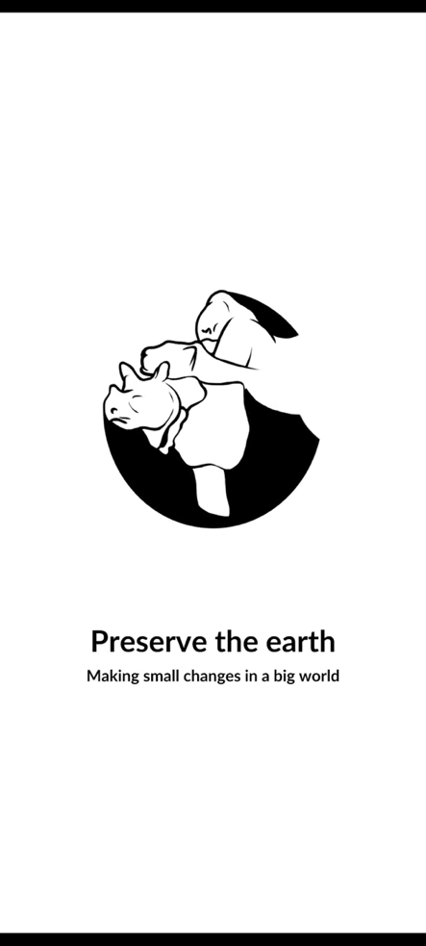

Cited

*7 best offline music apps that Need No WIFI (2022)*. OpenFMC. (2022, January 18). Retrieved May 9, 2022, from <https://openfmc.org/best-offline-music-apps/>

*8 things to know about palm oil*. WWF. (n.d.). Retrieved May 9, 2022, from <https://www.wwf.org.uk/updates/8-things-know-about-palm-oil#:~:text=Palm%20oil%20has%20been%20and,pygmy%20elephant%20and%20Sumatran%20rhino>.

